**Experiment Title-2_4**

**Student Name: Nitesh Sharma UID: 20BCS1600**

**Branch: CSE Section/Group-ON20BCS_NTPP_WM_702 {B}**

**Semester: 5th Date of Performance: 14/10/2022**

**Subject Name: java lab Subject Code: 20CSP-321**

**Subject Teacher: Reshma mam**

**1. Aim/Overview of the practical:** Create a menu based Java application with the following options.

1. Add an Employee

2. Display All

3. Exit

If option 1 is selected, the application should gather details of the employee like

employee name, employee id, designation and salary and store it in a file.

If option 2 is selected, the application should display all the employee details.

If option 3 is selected the application should exit.

**2. Task to be done/ Which logistics used:** To make employee management system.

**4. Steps for experiment/practical/Code:**

**import java.io.File;**

**import java.io.FileInputStream;**

**import java.io.FileOutputStream;**

**import java.io.IOException;**

**import java.io.ObjectInputStream;**

**import java.io.ObjectOutputStream;**

**import java.io.Serializable;**

**import java.util.ArrayList;**

**import java.util.Scanner;**

**@SuppressWarnings("serial")**

**class Employee implements Serializable{**

**int id;**

**String name;**

**float salary;**

**long contact_no;**

**String email_id;**

**public Employee(int id, String name, float salary, long contact_no, String email_id)**

**{**

**this.id = id;**

**this.name = name;**

**this.salary = salary;**

**this.contact_no = contact_no;**

**this.email_id = email_id;**

**}**

**public String toString()**

**{**

**return "\nEmployee Details :" + "\nID: " + this.id + "\nName: " + this.name + "\nSalary: " +**

**this.salary + "\nContact No: " + this.contact_no + "\nEmail-id: " + this.email_id;**

**}**

**}**

**public class exp_4**

**{**

**static void display(ArrayList<Employee> al)**

**{**

**System.out.println("\n--------------Employee List---------------\n");**

**System.out.println(String.format("%-10s%-15s%-10s%-20s%-10s", "ID","Name","salary","contact-no","Email-Id"));**

**for(Employee e : al)**

**{**

**System.out.println(String.format("%-5s%-20s%-10s%-15s%-10s",e.id,e.name,e.salary,e.contact_no,e.email_id));**

**}**

**}**

**@SuppressWarnings("unchecked")**

**public static void main(String[] args)**

**{**

**int id;**

**String name;**

**float salary;**

**long contact_no;**

**String email_id;**

**Scanner sc = new Scanner(System.in);**

**ArrayList<Employee> al = new ArrayList<Employee>();**

**File f = null;**

**FileInputStream fis = null;**

**ObjectInputStream ois = null;**

**FileOutputStream fos = null;**

**ObjectOutputStream oos =null;**

**try{**

**f = new File("N:/Java Work Space/Eclipse Programs/Employee Management Tool/src/EmployeeDataList1.txt");**

**if(f.exists())**

**{**

**fis = new FileInputStream(f);**

**ois = new ObjectInputStream(fis);**

**al = (ArrayList<Employee>)ois.readObject();**

**}**

**}**

**catch(Exception exp){**

**System.out.println(exp);**

**}**

**do**

**{**

**System.out.println("\n*********Welcome to the Employee Management System**********\n");**

**System.out.println("1). Add Employee to the DataBase\n" +**

**"2). Display all Employees working in this company\n" +**

**"3). EXIT\n");**

**System.out.println("Enter your choice : ");**

**int ch = sc.nextInt();**

**switch(ch)**

**{**

**case 1:System.out.println("\nEnter the following details to ADD list:\n");**

**System.out.println("Enter ID :");**

**id = sc.nextInt();**

**System.out.println("Enter Name :");**

**name = sc.next();**

**System.out.println("Enter Salary :");**

**salary = sc.nextFloat();**

**System.out.println("Enter Contact No :");**

**contact_no = sc.nextLong();**

**System.out.println("Enter Email-ID :");**

**email_id = sc.next();**

**al.add(new Employee(id, name, salary, contact_no, email_id));**

**display(al);**

**break;**

**case 2: try {**

**al = (ArrayList<Employee>)ois.readObject();**

**} catch (ClassNotFoundException e2) {**

**System.out.println(e2);**

**} catch (Exception e2) {**

**System.out.println(e2);**

**}**

**display(al);**

**break;**

**case 3: try {**

**fos = new FileOutputStream(f);**

**oos = new ObjectOutputStream(fos);**

**oos.writeObject(al);**

**} catch (IOException e1) {**

**e1.printStackTrace();**

**}**

**catch(Exception e2){**

**e2.printStackTrace();**

**}**

**finally{**

**try {**

**fis.close();**

**ois.close();**

**fos.close();**

**oos.close();**

**} catch (Exception e1) {**

**e1.printStackTrace();**

**}**

**}**

**System.out.println("\nYou have chosen EXIT !! Saving Files and closing the tool.");**

**sc.close();**

**System.exit(0);**

**break;**

**default : System.out.println("\nEnter a correct choice from the List :");**

**break;**

**}**

**}**

**while(true);**

**}**

**}**

**5. Screenshot of code with output:**

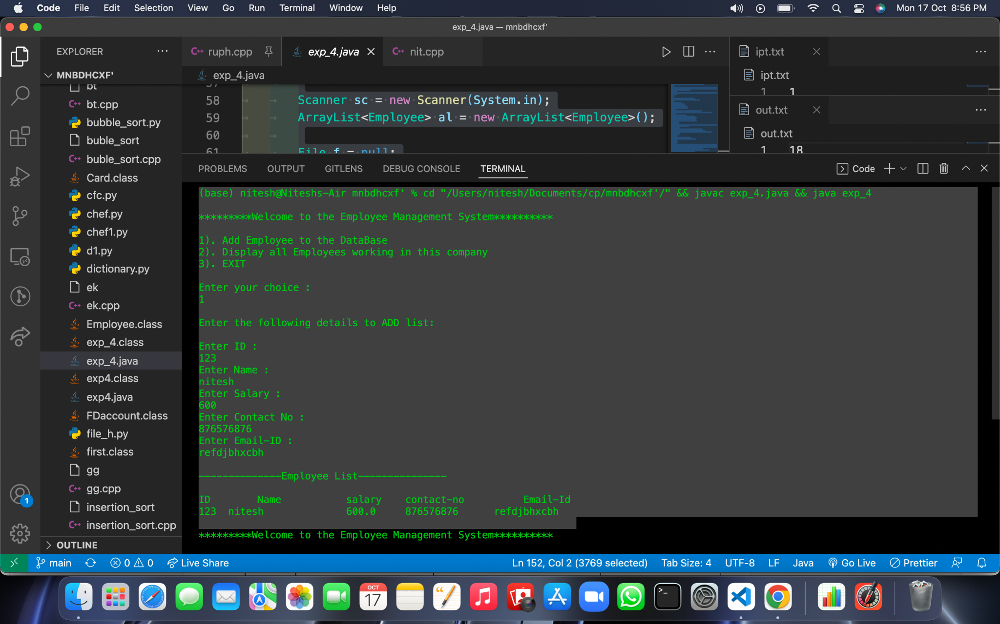

**Learning outcomes (What I have learnt):**

**1.We have learnt about the basic syntax of java**

**2.We have learnt about the inheritance concept of java.**

**Evaluation Grid (To be created as per the SOP and Assessment guidelines by the faculty):**

| Sr. No. | Parameters | Marks Obtained | Maximum Marks |
| --- | --- | --- | --- |
| 1. |  |  |  |
| 2. |  |  |  |
| 3. |  |  |  |
|  |  |  |  |